
BRADWAY PRIMARY SCHOOL

HEALTH & SAFETY POLICY

Reviewed: March 2025 by Governing Body
Next review date: March 2027

1 POLICY STATEMENT

This policy covers staff, pupils, visitors and any other users of the premises. The leadership team and the governing body are committed to ensuring the health and safety of everybody involved in the school. We aim to:

- Ensure that our school is always a safe and healthy place in which to work

- Ensure that all reasonable steps are taken to ensure the health, safety and welfare of participants during school trips and activities

- Regularly monitor and review safety procedures throughout the school

- Raise awareness among all users of the school as to their responsibility for themselves and others

- Investigate accidents and take steps to prevent a re-occurrence

- Ensure the dissemination of all relevant information from the LA and other bodies to the correct users

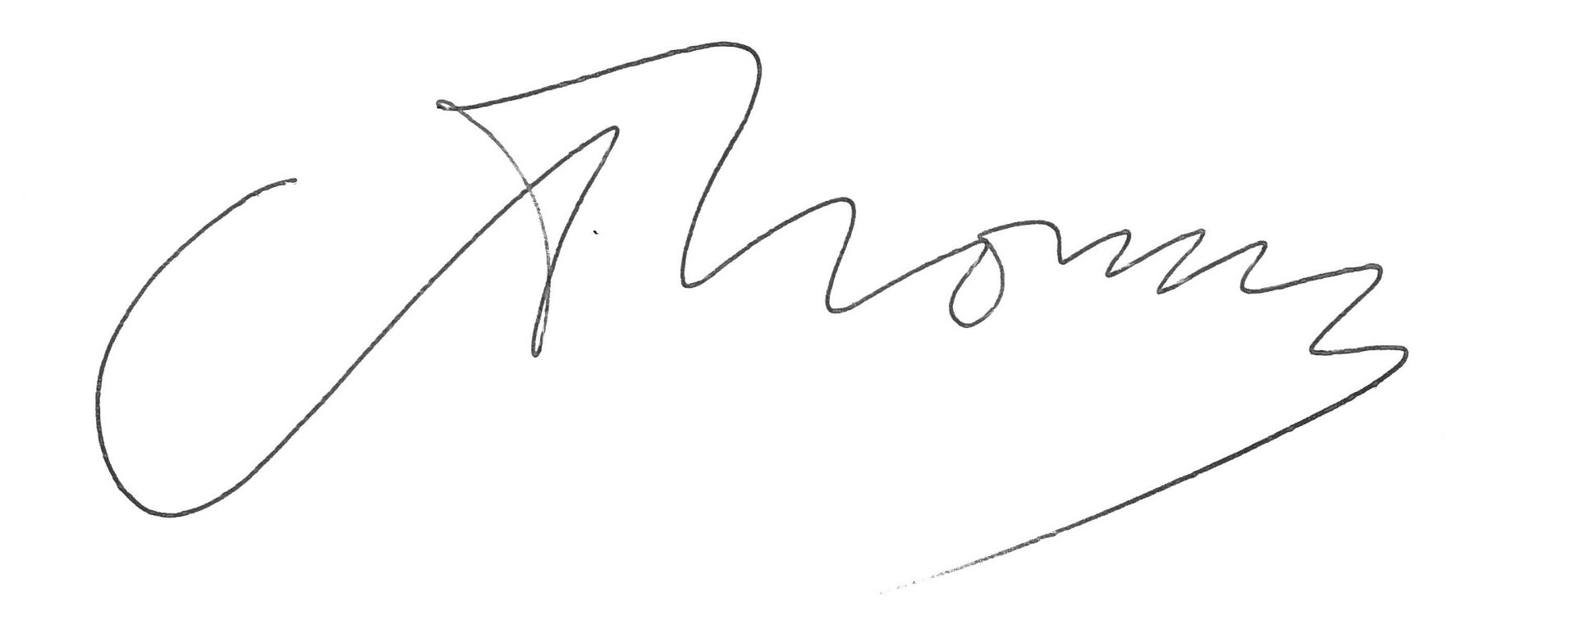
Signed:

Position: Headteacher

Date 13.03.2025

2 RESPONSIBILITIES

(i) Overall and final responsibility for the management of health and safety in this school is that of the Headteacher and the school governors.
Day-to-day responsibility for ensuring this policy is put into practice is the Headteacher and/or the School Business Manager and/or Building Supervisor.

(ii) All those who work in our school have the responsibility to take care of themselves, their colleagues, pupils and visitors in order to prevent accidents, injuries, cases of work-related ill health and provide adequate control of health and safety risks arising from work activities.

(iii) We will engage and consult with employees on day-to-day health and safety matters and provide advice and supervision to allow everyone to contribute to safe working. The Governing Body’s Premises/Health and Safety Sub-committee will meet regularly to oversee and monitor all safety issues.

3 GENERAL RESPONSIBILITIES

The Governors will:

- Ensure that adequate funding is provided from the school budget to enable the school to be organised and run in a safe and healthy manner.

- Where funding for particular hazards is the responsibility of the LA, e.g. structural problems, the governors, through the Headteacher, will inform the LA of the problem and assess the hazard in order to render the problem area safe.

- Deal with any health and safety problems brought to them by the Headteacher, staff or parents, through their termly meetings or any emergency meetings which may be called due to unforeseen circumstances.

- Nominate a Health and Safety Champion.

- Undertake an annual health and safety walk around/review, with the Headteacher, School Business Manager and Building Supervisor.

- Initiate a bi-annual review of the health and safety policy.

The Headteacher will:

- Ensure that health and safety is incorporated into the planning and
organisation of all school functions.

- Carry out suitable and sufficient assessments of hazards and risks to
staff members, pupils and other visitors and users of the school. Further, to act upon those assessments in order to reduce risk.

- Ensure the provision of adequate training, instruction and supervision.

- Provide necessary information to staff members and their representatives on health and safety matters.

- Ensure that staff members who are delegated to carry out particular
tasks are competent and fully aware of their responsibilities.

- Investigate any accidents or near misses and bring these, along with
any other health and safety problems to the attention of the governors.

All Staff Members will:

- Ensure that safe working practices are adopted at all times whether in
school or on educational visits.

- Ensure that they are fully aware of their responsibilities and follow any
Codes of Practice produced by the school or LA.

- Bring to the attention of the Headteacher any accidents, near misses,
dangerous equipment or situations which may occur whilst in school or on educational visits.

- Report to the Headteacher any problems which they feel that they cannot deal with themselves.

4 ACCIDENTS AND/OR NEAR MISSES

Even in a well run school accidents may still occur. This is how we deal with them.

All accidents and near misses which could have caused serious injury to our workforce or pupils will be investigated to find out what happened and how any similar incidents can be avoided. The Headteacher will ensure that accidents are investigated and that accidents which are reportable to the Health and Safety Executive and the LA are reported as necessary.

Serious accidents will be recorded by the School Business Manager using the incident investigation form which has been issued by the LA. Any accident reports will be examined by the Headteacher to see what lessons can be learnt and how similar incidents can be avoided.

The LA Code of Practice will be adhered to following an accident.

5 RISK ASSESSMENT

Risk assessments are a legal requirement. They must be recorded on the LA standard form and kept on the school premises. A copy should be sent to the LA. Risks should be assessed periodically and also any new process or change in circumstances will require an updated assessment. Educational visits also require a written risk assessment, for which we use the Evolve online approval system.

Shown below are the names of the staff undertaking risk assessments as well as details on when they will be carried out and our updating systems.

Building Supervisor/Headteacher - One risk assessment per term.

Building Supervisor - One electrical visual check per term.

Headteacher - Monitors above.

Building Supervisor /LA - Carry out electrical check as near as
possible on an annual basis.

Sport Safe Ltd - Carry out safety checks on large P.E.
apparatus annually.

6 FIRE

All sources of heat with the potential to cause fire, e.g. gas heaters, bunsen burners, cookers etc will be carefully monitored.

Fire drills are carried out once per term and recorded in the Fire Precautions log book. Fire evacuation education/instruction is posted throughout the premises.

Various other fire precautions will also be recorded in the log book, e.g. fire alarm and emergency lighting maintenance, fire extinguisher maintenance and fire officers visits.

Fire exits will be kept clear and fire doors remain shut in accordance with fire regulations.

The Fire Precautions log book is kept in the school office. The responsibility for ensuring that the book is kept up to date and that fire drills are carried out is with:

The Headteacher and the Building Supervisor

When the school requires painting, only paints producing a flame retardant surface will be used.

7 ELECTRICITY

Electricity must be treated as a priority with regard to maintenance and repair.

Electrical equipment is divided into two areas, these are fixed installation and portable equipment.

Maintenance and repair of fixed installations is the responsibility of Five Rivers Multi Academy Trust. However, if any faults or defects are identified within the school the Property Services branch of the LA will be notified immediately by the Building Supervisor.

Portable electrical equipment (e.g. anything with a plug head) is the responsibility of the school. Portable electrical equipment will be regularly maintained in accordance with LA advice which is set out to comply with the Health and Safety Executive guidance note GS23 (Electrical Safety in Schools). Any defective electrical equipment will be taken out of service immediately until checked by a competent person.

Any personal electrical equipment brought in by staff will be classed as school equipment and tested. Responsibility for arranging maintenance of electrical equipment is with the Building Supervisor.

8 MANUAL HANDLING

Pupils and staff must only lift equipment and furniture within their own individual capability. Manual handling training to be provided for appropriate members of staff.

9 SLIPS AND TRIPS

The potential for slips, trips and falls in school has been risk assessed and appropriate controls have been put in place. This includes working procedures for mopping floors and regular hazard spotting walk arounds.

10 MANAGEMENT OF ASBESTOS

Our asbestos management plan provided by the LA is held in our asbestos register in the main office. There is asbestos present in the main building and staff are aware that as long as the asbestos is in good condition and is not disturbed or damaged there is no risk to individuals.

11 CONTROL OF HAZARDOUS SUBSTANCES

The use of hazardous substances within the school will be kept to a minimum. The Building Officer will complete a COSHH assessment for any hazardous substances which are used on site. All substances that fall within the COSHH regulations are stored safely and securely out of reach of children.

12 WORK AT HEIGHT

All site/caretaking staff who undertake working at heights must have been adequately trained to do so. Teaching and other staff who assist in putting up displays in school have been given appropriate in-house training and advised that they must use appropriate access equipment and not climb on furniture to put up displays.

13 ADDITIONAL ARRANGEMENTS FOR KEEPING OUR SCHOOL SAFE

Codes of Practice are produced by the LA and cover many aspects of school safety. Copies of these are kept in the Headteachers’ Office and staff are made aware of their existence through weekly bulletins if appropriate and informed to consult them when carrying out a relevant task, e.g. planning an educational visit or setting up portable gas heaters in event of a breakdown.

Sufficient first aid boxes will be provided along with an adequate number of suitably qualified First Aiders.

School security will be enforced during lesson time by ensuring access is limited to the front entrance only and all visitors will have to report to reception and sign in.

Contractors are responsible for the Health and Safety of their employees and for their safe working practices, which must not constitute a hazard to staff, students and visitors to the school.

